

Digital Image Processing
Experimental Report

Name: An Mu
Student ID: 202383320031
College: ChangWang School
Major: Elec. & Info. Engineering
Supervisor: Jun Chen

December 20, 2022
TABLE OF CONTENTS

Experiment 1. Basic Computing of Digital Images 3

Experiment 1. Basic Computing of Digital Images

Experiment content:
This experiment covers five fundamental tasks in Digital Image Processing (DIP), implemented using MATLAB. The tasks are designed to introduce basic image representation, gray-level transformations (both linear and non-linear), geometric operations, and image resampling via interpolation. The five sub-experiments are summarized below:
Task | File | Description
Q1 | exp1Q1.m | Binary Checkerboard Generation — Constructs a 10×10 binary matrix representing a dual-value (black/white) checkerboard pattern using direct matrix indexing.
Q2 | exp1Q2.m | Linear Gray-Level Transformation — Applies the linear mapping $O=a⋅I+b/255$$�=�⋅�+�/255$ to a grayscale image (boy.jpg) with four different parameter pairs $\left(a , b\right)$ to observe contrast enhancement, contrast reduction, brightness shift, and color reversal (negative).
Q3 | exp1Q3.m | Non-linear Gray-Level Transformation (Gamma Correction) — Uses MATLAB's imadjust function to perform power-law (gamma) transformation on boy.jpg with$γ=0.5, 1.0 and 1.5$, demonstrating the effect of gamma encoding on image brightness.
Q4 | exp1Q4.m | Horizontal Mirror Flipping — Manually implements a left-right horizontal flip of the image (cameraman.tif) by re-indexing pixel columns without using built-in geometric transformation functions.
Q5 | exp1Q5.m | Image Resizing via Interpolation — Enlarges the image lena.jpg by a factor of 10× using three different interpolation kernels: nearest-neighbor, bilinear, and bicubic, and compares the visual quality of each method.

Experiment codes:

Experiment results:

3.1 Q1 — Binary Checkerboard Pattern
Observation: The displayed image shows a classic chessboard-like pattern of 5×5 alternating black and white squares, each square being 2×2 pixels in size. The MATLAB console also prints the numeric matrix x, confirming the 0/1 binary representation of the digital image.

Visualization:
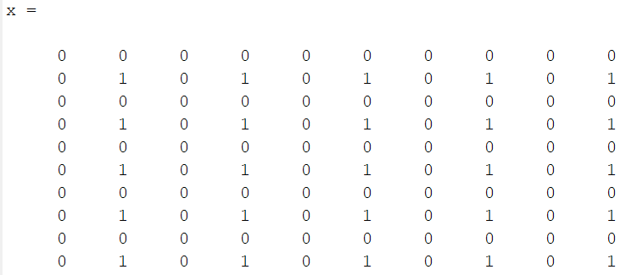 | 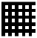

3.2 Q2 — Linear Gray-Level Transformation
Observation:
- Contrast Up ($a=2,b=-50$): Dark regions become darker, bright regions become brighter, yielding a high-contrast image with possible saturation/clipping at both extremes.
- Contrast Down ($a=0.5,b=-50$): The image appears flatter and more grayish, with reduced distinction between light and dark areas.
- Brightness Shift ($a=1,b=50$): The entire image is uniformly brightened by a constant offset, shifting the histogram to the right.
- Color Reversal ($a=-1,b=255$): Light areas become dark and vice versa, producing the negative of the original photograph.

Visualization:
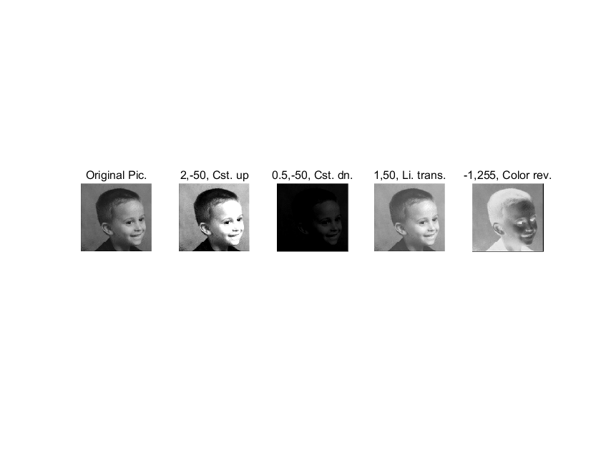

Q3 — Non-linear Gray-Level Transformation (Gamma Correction)
Observation:
- $γ=0.5$: Darker regions are expanded and midtones are pushed toward black, producing a darker overall appearance. Shadow details become more visible, but highlights are compressed.
- $γ=1.0$: The image is unchanged, serving as the control reference.
- $γ=1.5$: Brighter regions are expanded and midtones are pushed toward white, yielding a brighter, sometimes hazy appearance. Highlight details may become washed out while shadow regions are compressed.

Visualization:
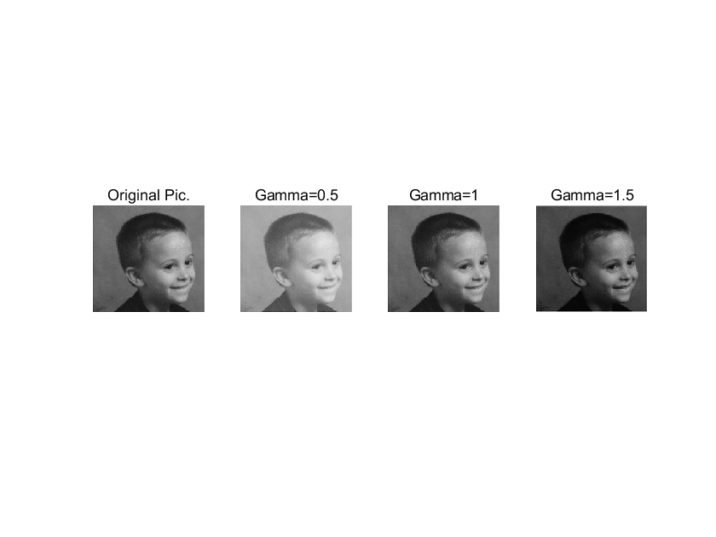

3.4 Q4 — Horizontal Mirror Flipping
Observation: The right subplot displays the horizontally flipped version of the cameraman photograph. All features (the photographer, camera, tripod, and background buildings) appear mirrored left-to-right compared to the original on the left subplot. The transformation is exact and lossless since it is a one-to-one pixel remapping.

Visualization:
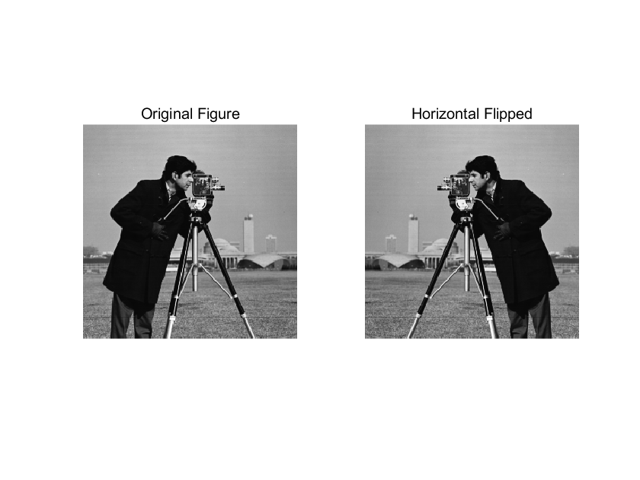

Q5 — Image Enlargement via Interpolation Methods
Observation:
- Nearest-neighbor: At 10× magnification, the image exhibits severe "staircase" artifacts (aliasing) and clearly visible 10×10 pixel blocks. Edges appear jagged and the overall result looks highly pixelated.
- Bilinear: The blockiness is eliminated, replaced by smooth transitions. However, edges appear somewhat blurred and the image may seem slightly soft or out of focus. No visible block artifacts are present.
- Bicubic: This method yields the best perceptual quality among the three. Edges are sharper and better preserved than bilinear, while smooth regions remain free of noise and artifacts. Some subtle ringing (overshoot) may be visible near sharp edges at this high magnification factor.
Visualization:
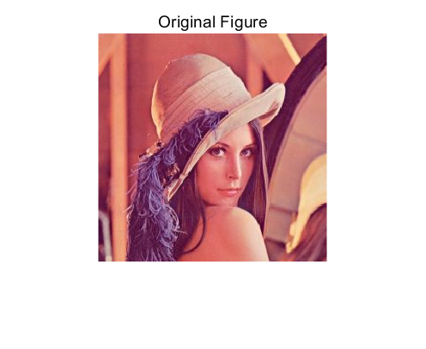 | 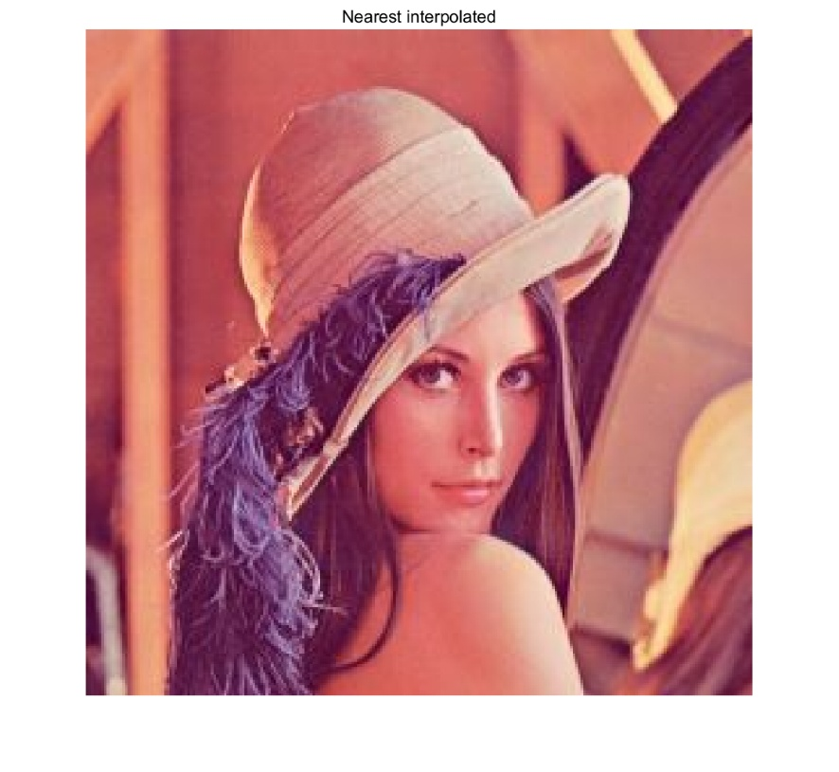
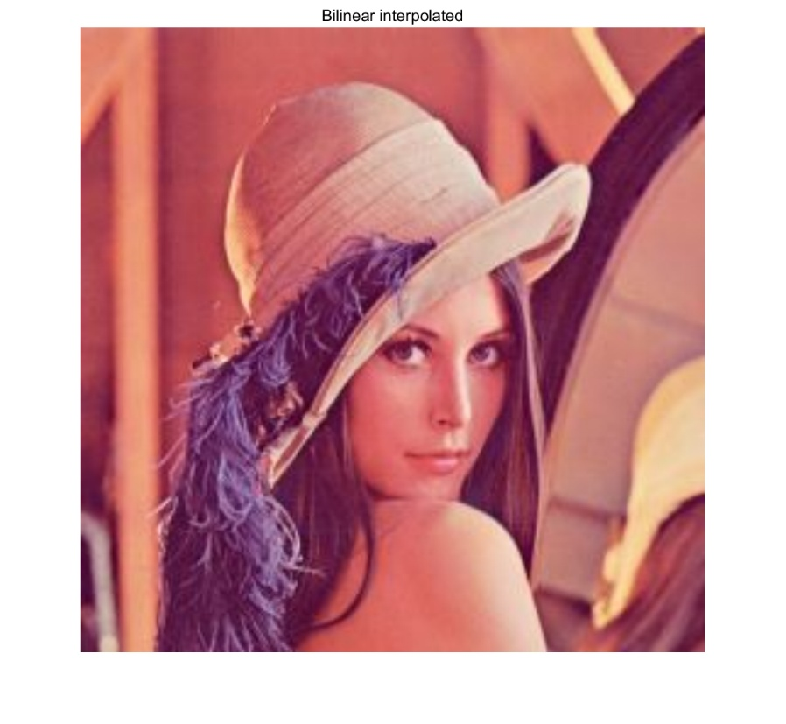 | 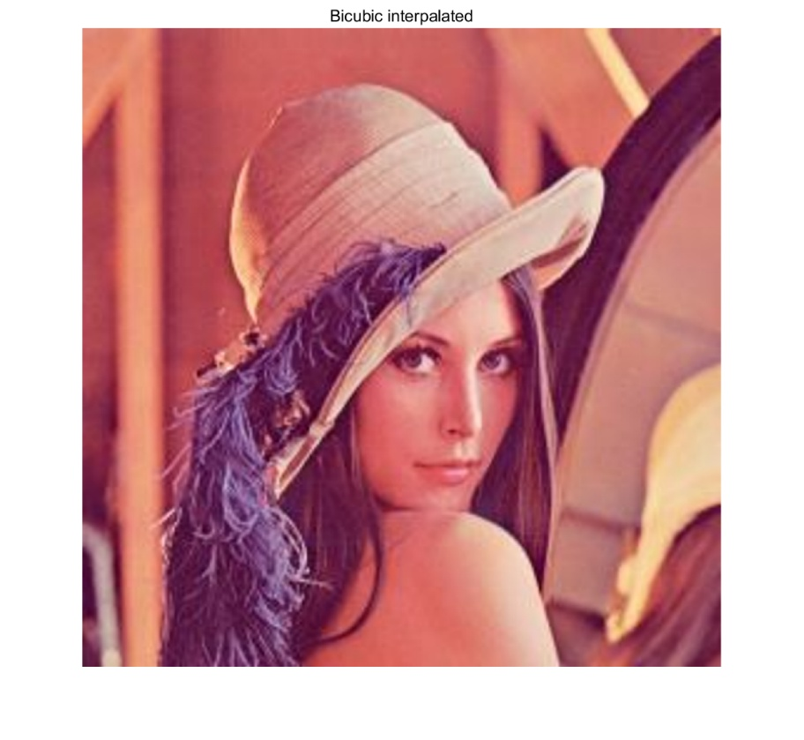
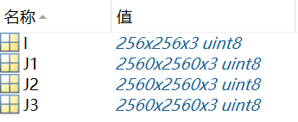

Experiment conclusion:
This first experiment in the Digital Image Processing course successfully introduced several foundational concepts:
Image as a Matrix: Experiment Q1 demonstrated that digital images are fundamentally 2-D numeric arrays, where each element directly corresponds to a pixel's intensity. This matrix representation underpins all subsequent image processing operations.
Point Operations (Intensity Transformations): Experiments Q2 and Q3 explored how modifying pixel intensities via mathematical functions — both linear ($O=aI+β$) and non-linear ($O=I^{γ}$) — can dramatically alter the appearance of an image. These point operations are memoryless (output depends only on the input pixel at the same location) and form the basis for contrast adjustment, brightness correction, and display calibration.
Geometric Transformations: Experiment Q4 illustrated that spatial-domain manipulation can be achieved by systematically remapping pixel coordinates. The horizontal flip, implemented manually via nested loops, reinforced understanding of how image coordinates and array indices correspond.
Image Resampling and Interpolation: Experiment Q5 highlighted the critical role of interpolation in image resizing. The visual comparison among nearest-neighbor, bilinear, and bicubic methods made clear that interpolation quality directly affects the fidelity of geometrically transformed images, with bicubic interpolation providing the best trade-off between sharpness and smoothness.
Collectively, these five sub-experiments provide a solid foundation for the more advanced topics to follow in subsequent experiments, including spatial filtering, frequency-domain processing, image restoration, and morphological operations. All code was implemented and verified in MATLAB, confirming the correctness of each algorithm.

